Face replacement and Gesture control(September 20)

Group member:Yang Wu

Rongfa Chen

Zheng Li

**ABSTRACT**

This project aim is to realize real-time mask swap, combine with hand-gesture control to determine different mode.

I.INTRODUCTION

This project is a three-people project. There are several goals.

*A. Background*

Many traditional arts face lost problems, face changing belongs to a type of local operas in China, Sichuan Opera, is popular in the Provinces of Sichuan, Yunnan and Guizhou. Face changing is not simply changing one’s facial makeup in a casual way, but is a special technique in the performance of Sichuan Opera. It refers to the changing of masks in quick succession to show different emotions and feelings of the character in the play.

*B. Product Introduction*

We present a novel product for real-time face replacement. This product is vision-based hand gesture recognition and face recognition. The user face will be replaced by different designs of facial make-up by different hand gesture. When user want to replace their face just show a hand gesture in camera, then the face will be changed by facial make-up. This is a simple and interesting product, the user will easy to learn, just need to move hands.

*C. Problem Facing And Relative Merits*

Based on the visual gesture recognition, the image sequence is collected by the camera, which can be processed and divided into the image Identification gesture. The best advantage of this method is simple input, low requirements for equipment, consistent with People's Daily interaction habits, but compared with the gesture recognition based on data glove, it is poor real-time capability and less hand gestures.

*D. Understanding some computer version theories*

We have learnt comp9517(computer version) for nine weeks. It’s time for us to review previous chapters, and there are many theories which need us to take time to understand. Besides these theories will help us to complete this project, and they are the bases for it.

II.SINGLE FRAME PROCESSING

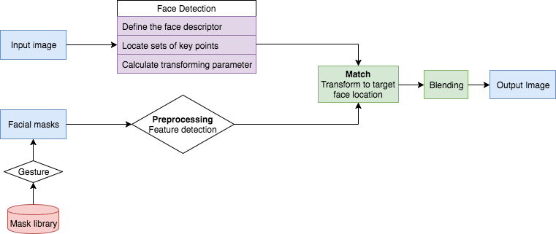

Building the mask library and pre-processing:

Build the mask library based on the facial mask collections of different characters in the opera and detect main features such as eyes and brows. The algorithm and parameters could be very different from those using on face detection as masks are different from looks of human face. This processing can be a one-time-run flow and saved in the library.

*A. Face Detection*

As shown in the flowchart above, it is a single frame processing, which be combined into video when we are doing whole video or real time mode. Define the descriptors on human face and locate those key points we are looking for, which provides parameters for the later matching.

*B. Matching and Blending*

Transform the required mask from the gesture interaction to the target face location and align it right above the face, based on the parameters calculated in previous steps. Blend the edge and corner of the mask to the face, making the result more natural.

*C.Possible algorithms and principles*

* Feature descriptor:

Bias and gain normalisation (MOPS); Scale invariant feature transform(SIFT), PCA-SIFT and SURF

Gradient location-orientation histogram(GLOH):

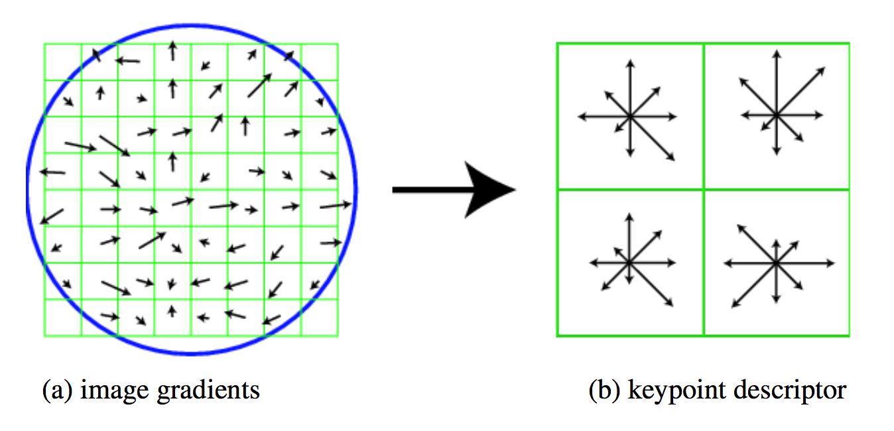

* Performance of local descriptor

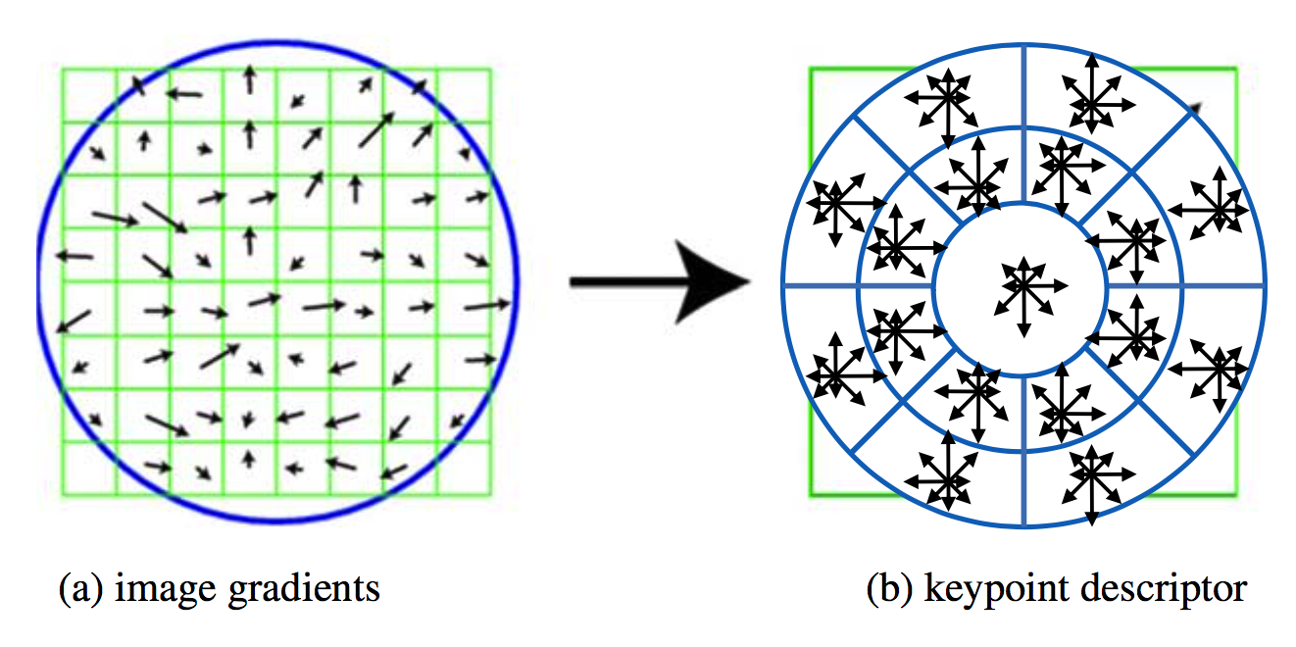

* Feature matching:
* Nearest neighbour distance ratio(NNDR):

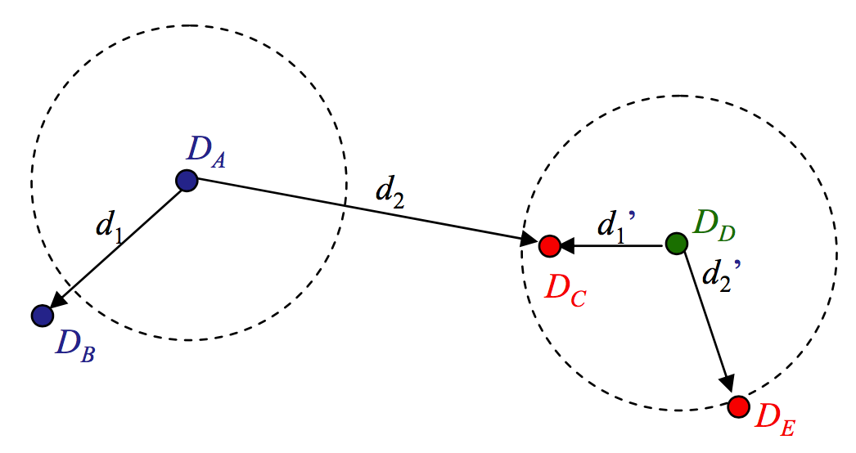

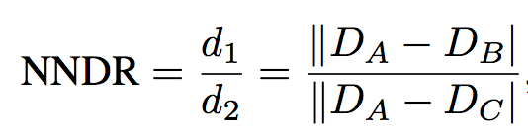

Efficient matching (K-d tree and best bin first search); Robust least squares and RANSAC[1]:

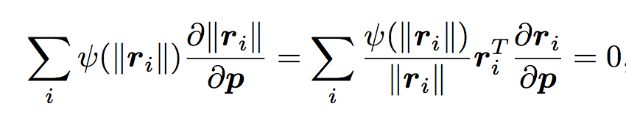

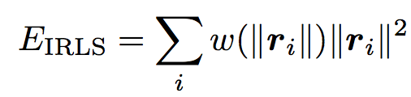

2D Alignment[1]:

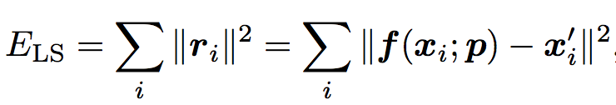

Where

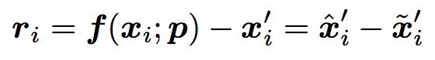

Weighting each squared residual by its inverse covariance:

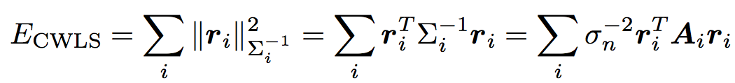

Temporal Clustering and Frame Selection[2]:

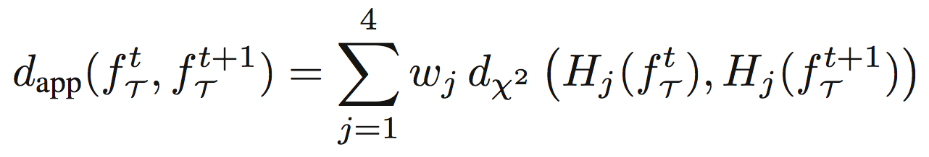

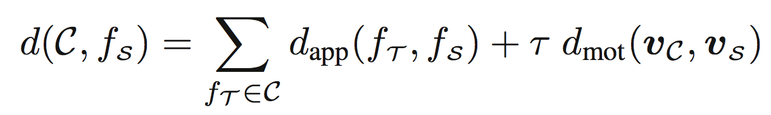

*D. Hand Gesture*

It is interesting to use gesture to control the displayed result, so we have some ideas about gesture control to our project.

In order to implement the gesture control, we should get the different gesture model. It is easy to catch hands position, and then just use background subtraction and threshold so we can get the hands. Then just use fingertips to transform the hands to a polygon graph and set the control point in the convex corner.

III.EVALUATION

Finally, we need some data to evaluate the performance of our project[3]. Here we choose some idea. The first one is FPS, it is easy to get the FPS number just use 1 second divide each frame running time. Secondly, the accuracy of masks match is also important, we will use the feature points and size deviation between mask and the original face to get it performance. Thirdly, is about reaction which is the time between the face catching and face changed completely.

IV.Planning

This is a group work and there are several sub projects which can help to complete whole project. So it is necessary to make a plan.

*A. Week 10*

Each of us should review the lectures and search some related knowledge online. To achieve this, we should arrange several times studying together and deal with some problems. Besides, we should read some blogs which are related to our project.

*B. Week 11*

Write the code relates to the face detection. And run it on pictures and live videos.

*C. Week12*

Write the code related to gesture control and combined with face detection.

*D. Week13*

Write the code related to add stickers and combined with precious code. And demo it with some testing video.

*IV.REFERENCE*

[1] Szeliski, Richard. Computer Vision: Algorithms and Applications (September 3, 2010 draft)

[2] Pablo Garrido, Levi Valgaerts, Ole Rehmsen, Thorsten Thormahlen, Patrick Perez, Christian Theobalt; Automatic Face Reenactment. The IEEE Conference on Computer Vision and Pattern Recognition (CVPR), 2014, pp. 4217-4224

[3] Han Youngmo. A Low-Cost Visual Motion Data Glove as an Input Device to Interpret Human Hand Gestures[J]. Transactions on Consumer Electronics,2010,56(2):501-509.